# Department of Computer Engineering

**Academic Term: July-November 2023**

# Rubrics for Lab Experiments

|  |  |  |
| --- | --- | --- |
| **Class** | **: B*.E. Computer*** | **Subject Name :*BDA*** |
| **Semester** | **: VII** | **Subject Code :** |

|  |  |
| --- | --- |
| **Practical No:** | 4 |
| **Title:** | Write a program to implement Matrix Multiplication algorithm using Map Reduce |
| **Date of Performance:** | 03-09-2023 |
| **Roll No:** | 9427 |
| **Name of the Student:** | Atharva Prashant Pawar |

**Evaluation:**

|  |  |  |  |  |  |
| --- | --- | --- | --- | --- | --- |
| **Performa nce Indicator** | **Below average** | **Average** | **Good** | **Excellent** | **Marks** |
| **On time**  **Submission (2)** | Not submitted(0) | Submitted  after deadline (1) | Early or on time submission(2) | --- |  |
| **Test cases and output (4)** | Incorrect output (1) | The expected output is verified only a for  few test cases (2) | The expected output is  Verified for all test cases but is not presentable (3) | Expected output is obtained for all test cases. Presentable and easy to follow (4) |  |
| **Coding efficiency (2)** | The code is not structured at all (0) | The code is structured but not efficient (1) | The code is structured and  efficient. (2) | - |  |
| **Knowledge( 2)** | Basic concepts not clear  (0) | Understood the basic concepts (1) | Could explain the concept with  suitable example (1.5) | Could relate the theory with real world application(2) |  |
| **Total** |  | | | | |

**Signature of the Teacher :**

**Code:**

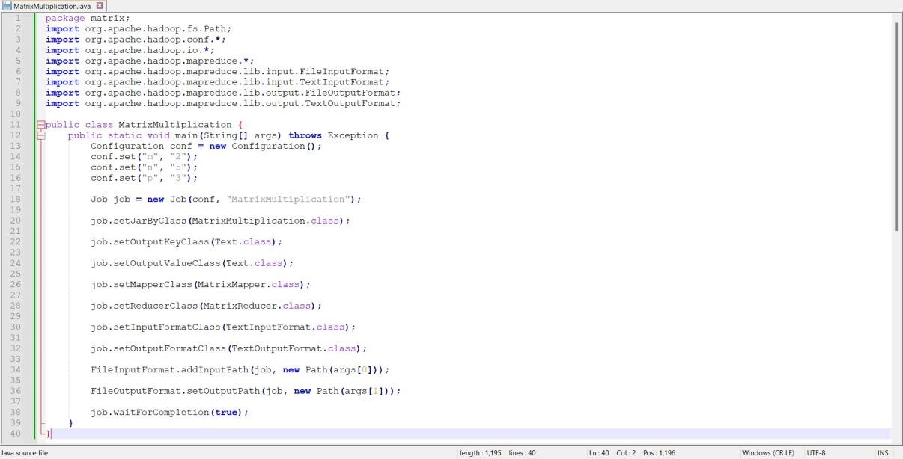

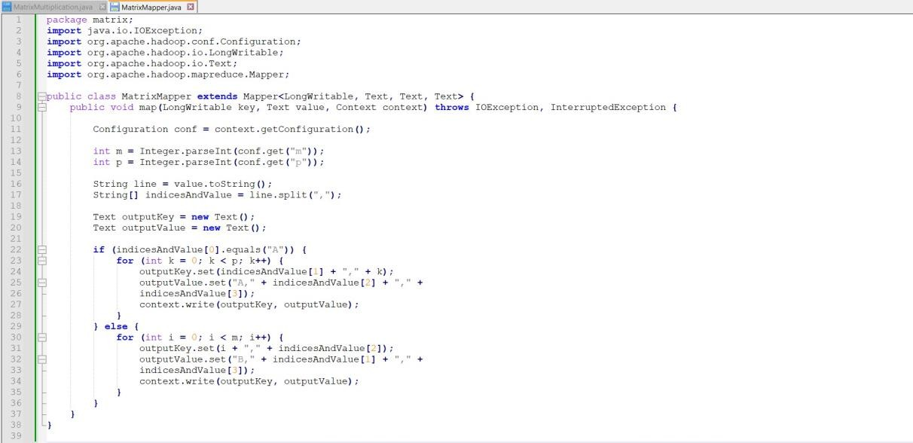

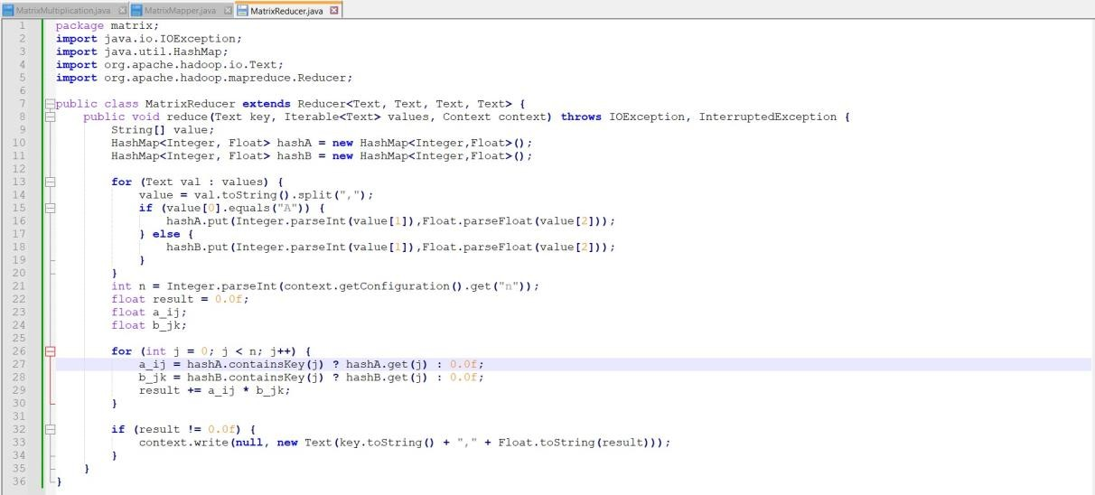

**OUTPUT:**



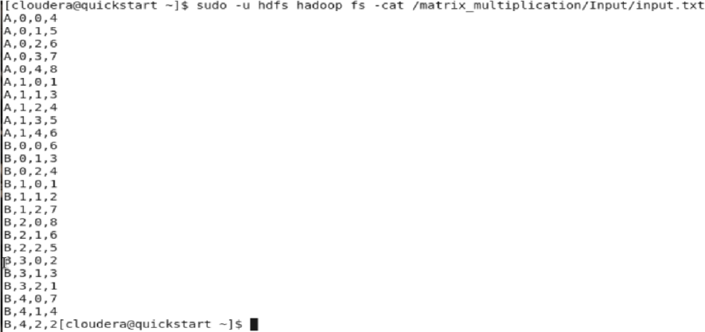

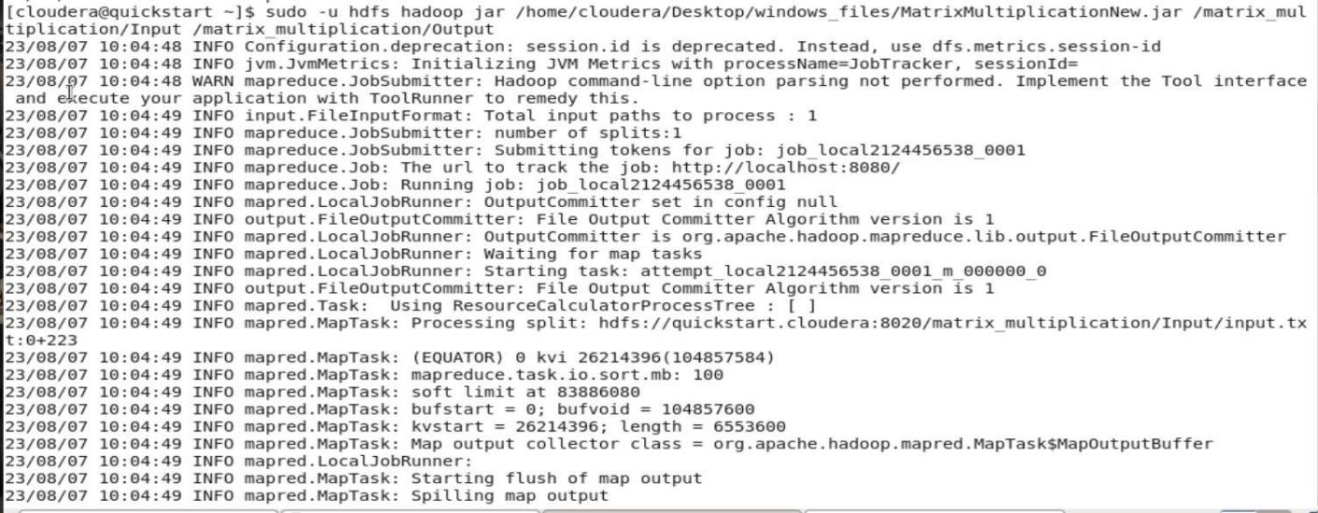

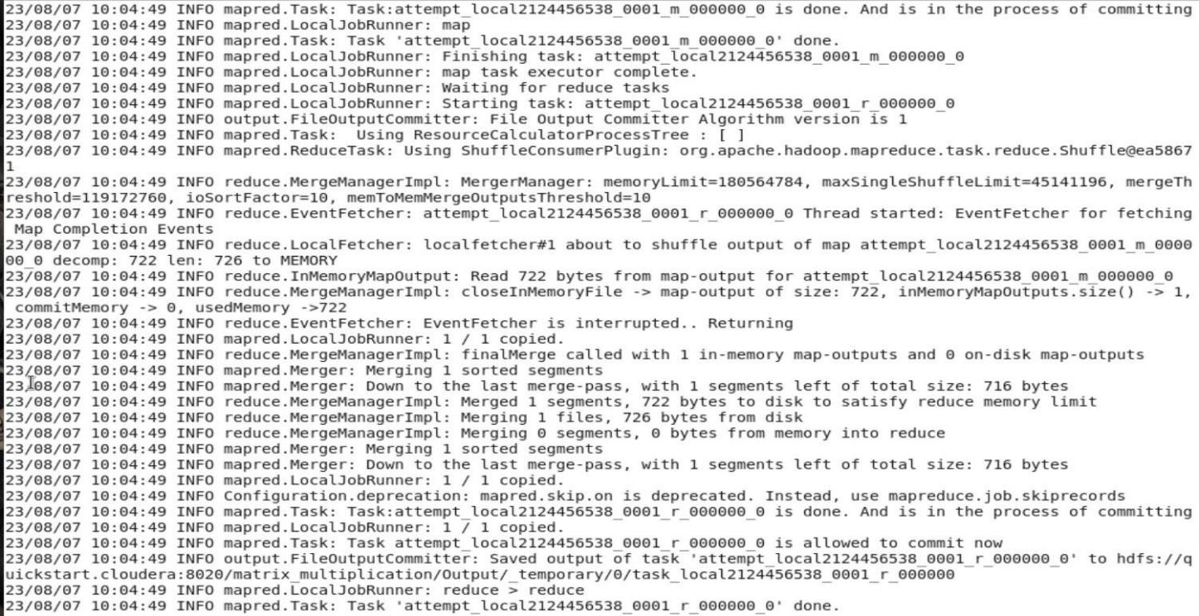

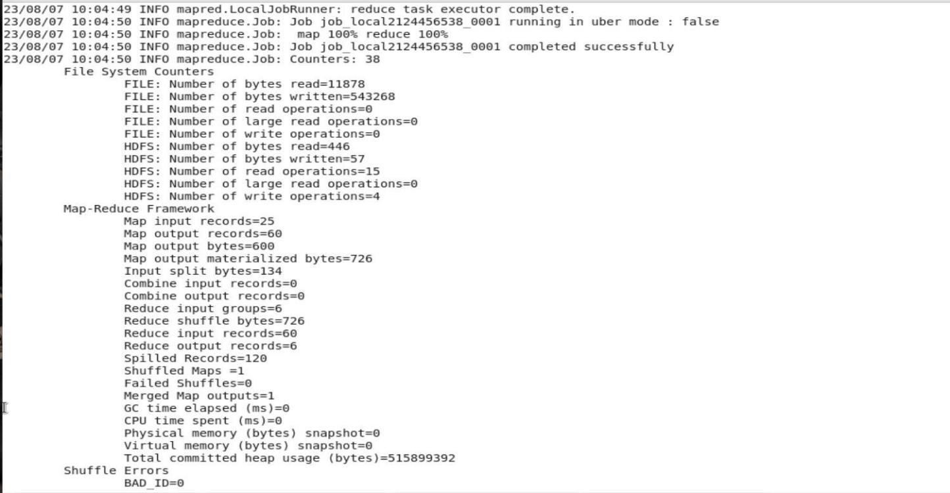



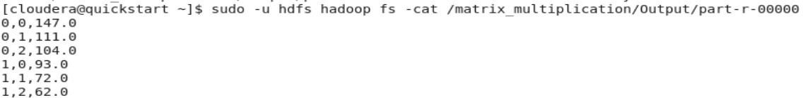

**Post lab**

